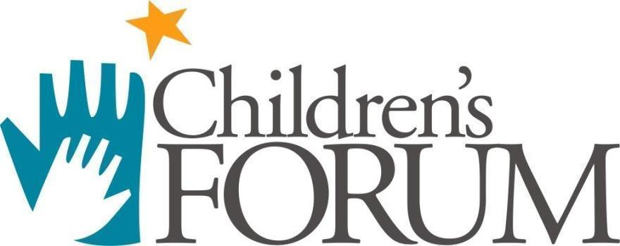

President’s Report

Activities and Progress

Strategic Plan

2017-2018

…because kids can’t wait!

Vision

Connected and engaged communities supporting children for lifelong success.

Mission
Through collaboration, the Forum builds and supports systems to promote positive experiences and outcomes for young children.

Guiding Principles: Good public policy is informed by research. The use of sound research to increase awareness and advocacy on children’s issues and the field of child care and early learning is fundamental. Our guiding principles, therefore, are informed by research and best practices:

- Parents are the primary educators of their children; yet some parents face barriers that seriously limit their ability to be effective parents. Proven programs and adequate resources must be available to assist parents in achieving the best possible outcomes for their children.
- The foundation for physical, social and emotional capabilities is largely set during children’s first few years of life and is essential to their future cognitive and academic success as well as their ability to function well in society.
- Children have the right to warm, responsive, and nurturing care from their parents and caregivers.
- Children are entitled to high quality early learning experiences including before and after school enrichment provided not only by their parents but by compassionate, knowledgeable, and trained practitioners as well.
- Families of children with disabilities and special health care needs have unique challenges and should have access to services and adequate resources designed to meet their needs and assistance to navigate systems that can help support them.
- Formal education and ongoing professional development for practitioners are critical to the optimum development of children given the correlation between practitioner knowledge, skills, and practices and improved child outcomes for later success.
- Compensation parity for early childhood and afterschool practitioners must be promoted to positively impact recruitment, retention, quality and commitment to the field.
- Collaboration with other local, state, and national organizations/agencies is the most effective strategy for supporting children, families, and practitioners to achieve shared goals.
- Professionalism, accountability, honesty, respect, integrity and excellence are minimum expectations for Forum staff and members of the board of directors.
Adopted as edited by the board of directors, October 2010 Reviewed and affirmed by the board of directors, December 2012, March 2014, October 2014, December 2016, March 2017

STRATEGIC PLAN PROGRESS 2017-2018

Goal 1
The Forum will provide innovative, responsive assistance, support and professional development educators, stakeholders, and families at the local, state and national levels.

Objectives
The Early Learning Career Center will serve as the hub to provide responsive guidance, professional development supports, outreach, resources, technical and scholarship assistance to programs and educators in Miami-Dade County.
The Teacher Education and Compensation Helps (T.E.A.C.H.) Early Childhood® Scholarship Program providing scholarships to improve compensation, education, and retention in the field of early care and education will continue to be a valuable resource to the field. The results will be reported to policymakers and funders.
The Forum will operate and manage the Palm Beach Registry Services for the Children’s Services Council and the Miami-Dade Registry for The Children’s Trust.
The Child Care Evaluation Services program will provide services under contract with the Department of Children and Families (1) to evaluate applications of recognized accreditation associations for inclusion in the state’s Gold Seal Quality Care program and maintain the Gold Seal database, and (2) to evaluate applications of early childhood training providers for eligibility as Florida Child Care Professional Credential (FCCPC) training program providers.
The Forum will develop and deliver high quality training through summits, workshops, conferences, etc..
The Forum will maintain its status as an authorized provider for International Association of Continuing Education and Training (IACET).

Goal 2
The Forum will generate and disseminate valid, reliable and current best practices, data and research informing decision-making and measuring outcomes.

Objectives
Relevant research studies and policy briefs will be disseminated to various audiences to include practitioners and policy makers to inform the field and improve practices.
Grant proposals will include research and evaluation components to test efficacy of proposed strategies and measure outcomes for early childhood educators and ultimately the children they serve.

Goal 3
The Forum will provide collaborative leadership to promote effective policy advocacy for children and families

Objectives
Facilitate, participate and serve on various local, state, and national level leadership initiatives to promote effective public policy and best practice.
Engage in advocacy efforts that promote the philosophy of the organization following applicable guidelines under state and federal regulations.
Present and display at local, state, and national conferences on relevant topics demonstrating the expertise of Forum staff and value of programs administered.
Support the board of director’s priority to effectively engage business leaders in early childhood policy in Florida. (Bob, how do we want to develop this further?)
Maintain and expand shared services agreements with partners such as FLAEYC and FHSA.

Goal 4

The Forum will maintain a sustainable marketing and outreach plan to educate stakeholders and the public about the value of high quality early learning ,school age and early intervention services

Objectives
Continue to assess the needs of the field and secure funding to support the mission of the organization.
Write and promote news, stories, and op-eds in various media throughout the state.
Promote advocacy, effective policies and practices through the Forum communications.
Engage the field through the Forum’s membership program.
Maintain a presence on social networking sites (Facebook,Twitter, Instagram, Pinterest and YouTube) to increase partnerships, build awareness of programs/services and receive online donations.
Write and disseminate a quarterly newsletter to promote collaboration among providers of services for young children.
Promote and expand professional development systems throughout the state to provide career pathways for early childhood and afterschool educators..
Bring positive recognition to the Forum for the quality and excellence of the work.

Goal 5

The Forum will increase awareness of compensation disparities for the early care and education workforce. .

Objectives
Provide wage and salary stipends through the successful implementation of the Child Care WAGE$ Program.

Goal 6
The Forum will provide collaborative leadership to improve systems of care, education, and healthy development for children. .

Objectives
Enhance the Professional Development Registry to serve as a resource for training and scholarship management, and to inform decision-making.
Maintain websites that will serve as the information and resource hub for the early learning field.

Provide leadership and administration of the Help Me Grow Florida project to increase the access and availability of services for children and families.
Support diversity in the early learning and afterschool workforce.

Goal 7
The Forum will be administered in a cost effective and efficient manner ensuring adequate resources are available to carry out the mission of the organization.

Objectives
Respond to relevant Invitations To Negotiate or Request for Proposals that are consistent with the strategic plan goals. Assure that the potential revenue, social capital and/or return on investment justifies the allocation of resources
Increase unrestricted revenue.
Provide monthly financial reports to the Board ensuring board members are informed on the financial status of the Forum.
Maintain positive audit results and monitoring reports that reflect the quality of our work..

Maintain quality assurance practices to ensure the ongoing quality improvement of services.
Strengthen the internal culture of the Forum through staff recognition and professional development opportunities.

